XN PROJECT: GROUP PROJECT (DRAFT)

Sean McLean
Paula Andrea Romero Melo
Gauri Udaysing Shinde
Theodore R. Smith
College of Professional Studies, Northeastern University

Introduction
This report outlines a strategic plan to enhance digital sales and marketing for Yeoman Technology Group (YTG) using Amazon data. The analysis focuses on optimizing advertising strategies, boosting conversion rates, and improving brand positioning, emphasizing the need to target high search query areas and grasp market dynamics. Recommendations include advanced predictive modeling and the study of temporal trends to refine strategies. Regular stakeholder engagement and feedback are crucial for aligning outcomes with expectations, highlighting the importance of data-driven approaches in transitioning to digital platforms and achieving a competitive edge in the digital marketplace.
Executive Summary
The objective of this project is to identify areas of interest for Yeoman Technology Group. By analyzing the dataset, each team member found patterns providing insights for potential deliverables. The main focus areas identified are Market Share Clicks and Search Query, which will guide the strategic recommendations for the client.
Business Problem
The challenge is to help pre-Internet brands improve their digital sales without disrupting existing wholesale and retail channels. The strategy involves utilizing Amazon data to enhance client understanding of pricing, advertising, and merchandising programs. The goal is to create scalable Brand Influence and Ad Spend Optimization models to improve advertising strategies and brand positioning on Amazon.
Project Scope
To maintain a professional project's workload, defining the project's goal and objectives is crucial to focus efforts and avoid unnecessary work. The team's needs for this project are to find business answers and insights from the provided dataset. The results need to be packaged concisely and clearly. The scope involves exploratory data analysis (EDA) focusing on five popular brands and the five smallest brands to determine correlations between spending and profit. Acceptance comes strictly from sponsor feedback, and the goal is to provide general insights and then finalize the results based on feedback. Primary constraints include limited access to the sponsor and the dataset provided by YTG, which helps focus the analysis. The primary stakeholders are YTG, the course instructor, and the project team. Regular updates and feedback sessions are crucial. Ethical considerations include ensuring ethical handling of data, maintaining confidentiality, and integrity in analysis.
Analytical Approach
The analytical approach includes exploratory data analysis (EDA) and various business intelligence (BI) and machine learning techniques. EDA involves descriptive statistics, data visualization, correlation analysis, conversion funnel analysis, and segmented analysis. BI analysis includes trend analysis, performance metrics calculation, comparative analysis, and creating visualizations like dashboards and heatmaps. Machine learning analysis encompasses predictive analytics, clustering, classification, regression analysis, and natural language processing (NLP). Specific models developed include a Brand Influence Model to quantify brand impact on search queries and an Advertising Effectiveness Model to optimize advertising spend and calculate ROAS.
Analytics / Visuals
Key insights from the analysis include the dominance of a few brands, high barriers to entry, and significant competition intensity, indicating a mature market. The relationship between search query volume and ad impressions suggests focusing advertising on high search query areas to increase ad visibility. Brand frequency analysis shows the strong presence of top brands, with niche or newer entrants having lower frequencies. Market share analysis reveals a wide range of shares among brands, highlighting the potential for smaller brands to increase sales and profit.
The clicks versus purchases analysis indicates low engagement and conversion for most queries, with recommendations to optimize high-click, low-purchase queries. Simplified distribution of clicks by brand shows dominance of top brands like Dash & Albert and Kaspene Home. Association mining reveals key metrics such as support, confidence, and lift, useful for identifying common combinations, targeted marketing, and enhancing recommendation systems.
Recommendations & Findings
Key Insights from Brand Share Histogram
- Market Dominance: A few brands dominate with most percentages clustered between 75-100%, indicating significant market concentration.
- Barriers to Entry: High prevalence of 0% suggests barriers to entry such as strong brand loyalty and high entry costs.
- Competition Intensity: The wide gap between 0% and dominant brands indicates a highly competitive market environment.
- Market Maturity: Concentration at extremes suggests a mature market, posing challenges for new entrants but opportunities for differentiation through strategic innovation and marketing.

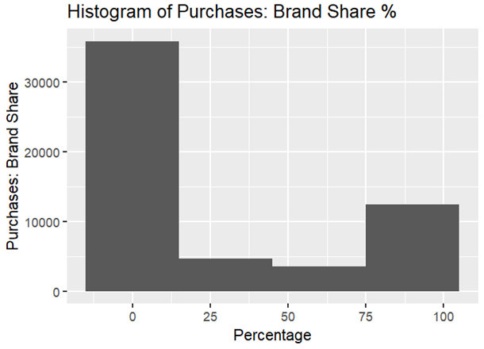
Search Query Volume vs. Impressions
- Observation: Linear relationship between search query volume and ad impressions.
- Implication: Focusing advertising efforts in areas with high search query volumes may be more effective in reaching a broader audience and increasing ad visibility.
Brands Frequency
- Brand Popularity: Strong market presence in the top five brands.
- Niche Players: Lower frequencies may indicate niche players or newer entrants.
- Outliers: No evidence of outliers.
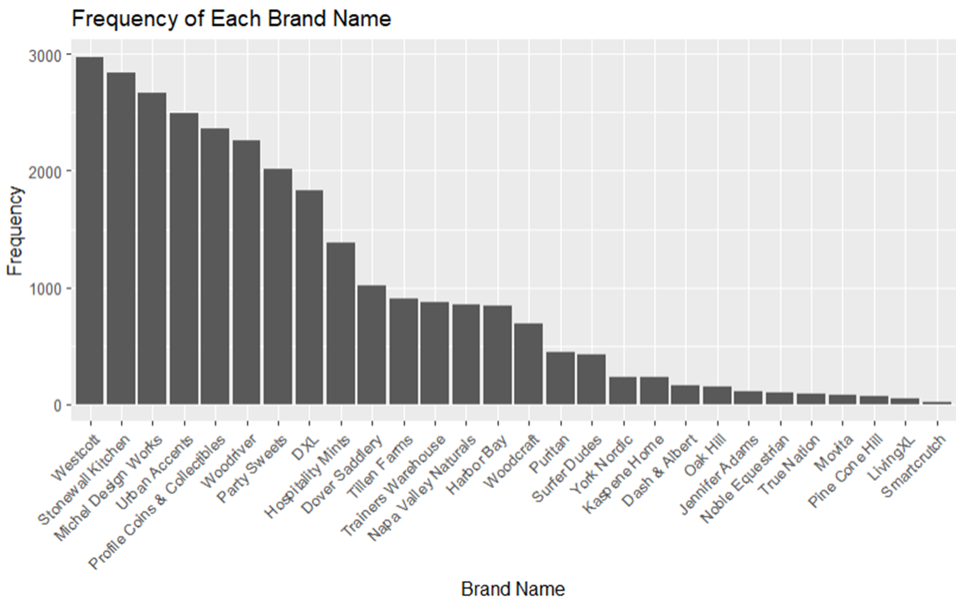
Market Share by Company
- Observation: Wide range of market share for each company/brand.
- Opportunity: Smaller market shares have potential for greater percentage increases in sales and profit.
- Question: Are smaller brands willing to invest the effort and capital to try changing?
Clicks vs. Purchases
- Data Concentration: Most queries have low clicks and purchases, indicating low engagement and conversion.
- Outliers: Some queries have high clicks but low purchases, highlighting inefficiencies in conversion.
- Recommendation: Focus on optimizing high-click, low-purchase queries to improve overall performance.

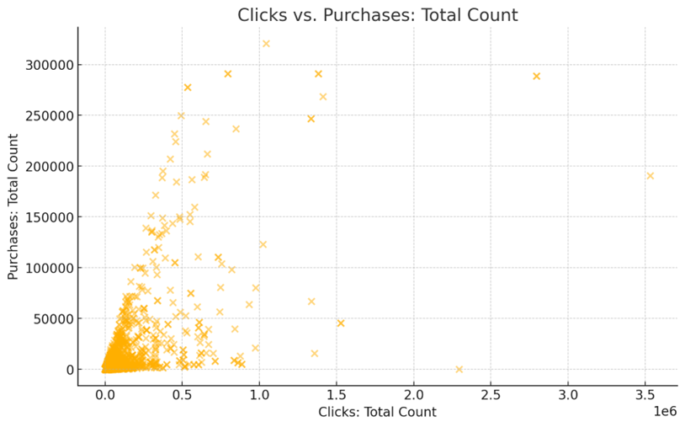
Simplified Distribution of Clicks by Brand
- Dash & Albert: The largest share of total clicks, indicating high user interest and engagement.
- Kaspene Home: Substantial portion of clicks, reflecting strong brand visibility.
- Urban Accents: Significant share, suggesting effective query performance.
- PineCone Hill: Moderate clicks, indicating steady user interest.
- Stonewall Kitchen: Noticeable portion of clicks, showing competitive engagement.
- Others: Aggregated smaller brands, highlighting the dominance of top brands.

Association Mining of Dataset
- Understanding key metrics involves support, which measures the frequency of itemsets in the dataset; confidence, which indicates the reliability of the rule and how often items appear together; and lift, which reflects the strength of association, with higher values indicating stronger associations.
- Interpreting the scatter plot involves recognizing that high support and confidence indicate reliable but less frequent itemsets, valuable for strong associations, while high lift suggests strong associations with potential cross-selling opportunities.
- Additionally, a dense low support cluster contains many itemsets with low frequency but potentially high confidence and lift, indicating interesting associations.
- The implications for Amazon include identifying popular itemsets for inventory and promotions and leveraging reliable associations with high confidence rules for targeted marketing.
- Uncovering hidden relationships through high lift insights can enhance recommendation systems and boost sales through strategic product placements.
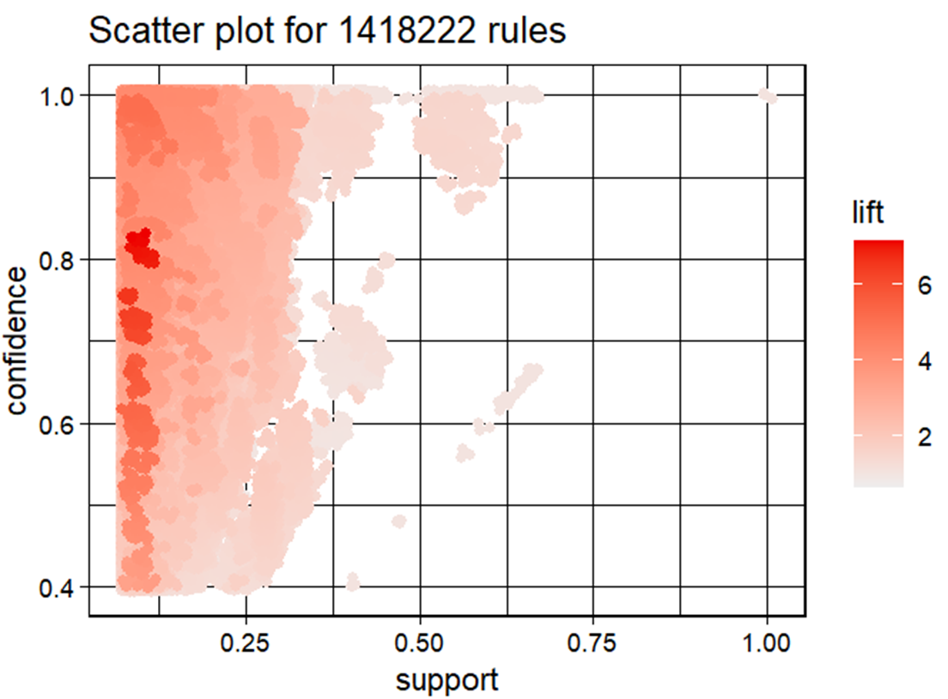
Recommendations include optimizing advertising strategies by focusing on high search query areas, enhancing brand positioning using insights from brand share and search query analysis, and improving conversion rates by addressing high-click, low-purchase queries. These recommendations aim to enhance digital sales and marketing strategies for YTG.
Future Research
Future research should focus on continued refinement of the analysis to provide specific guidance for YTG. Exploring temporal trends can help understand seasonal trends and long-term shifts. Advanced predictive modeling can forecast future sales trends and customer preferences, aiding in more accurate business decisions.
Milestones
Key milestones include analyzing the pros and cons of the XN Project, deeper exploration of the project, creating an interview guide, developing a project roadmap, presenting mid-term progress, creating a project scope document, submitting a project draft and final draft, preparing a presentation slide deck, and giving the final project presentation. Each milestone has specific dates and summary of activities.
Key Risks and Strategies
Key risks include data security and privacy, consistency and quality of data, and integration with current systems. Strategies to mitigate these risks include using strong encryption protocols and strict access controls, implementing strong data validation and cleaning procedures, and creating precise integration plans and schedules. Training and support for the company team will also facilitate successful implementation of new models.
Stakeholder Engagement and Feedback Integration
Regular engagement with stakeholders is crucial for alignment and refining analysis. Feedback sessions will help ensure the final deliverables meet the desired standards of quality and relevance. This iterative process fosters open communication channels and receptiveness to constructive criticism, enhancing the value of recommendations and increasing the likelihood of successful implementation by YTG.
Keys to Successful Project Management
Successful project management involves agreement on acceptable quality levels, efficient resource management, regular feedback sessions, and clear documentation. Ensuring high quality within the limited time frame requires balancing the pursuit of quality, resource allocation, and adherence to the project schedule. Regular updates and meetings help track progress and address any issues promptly. Maintaining thorough documentation ensures transparency and ease of review.
Conclusion
This report presents a strategic plan to boost digital sales and marketing for the Yeoman Technology Group (YTG) through the utilization of Amazon data. The analysis centers on refining advertising strategies, increasing conversion rates, and strengthening brand positioning. Key findings emphasize the significance of focusing on high search query areas and comprehending market dynamics. Recommendations include employing advanced predictive modeling and examining temporal trends to enhance strategies. Regular engagement with stakeholders and incorporating their feedback are essential for meeting expectations. This project highlights the importance of data-driven strategies in transitioning to digital platforms, enhancing business performance, and gaining a competitive edge in the digital market.

References
Champigny, A. (2024, May 18). 6 Ways to Measure Your Consulting Firm’s Performance. Deltek.
Guiding Metrics. (2024, May 18). The Management Consulting Industry’s 10 Most Critical Metrics.

